McCain, Alena Nicole

November 19 2020

Blocks World

CS 6850: GRADUATE

Contents

Abstract 2

Introduction 3

Problem Statement 3

Definitions 3

Methodology 4

Additions/Modifications 4

General Idea 4

Ranking System 4

Producing Child States 5

Program Optimization/Reducing Redundancy 6

Results 7

Execution Walkthrough/Example(s) 7

Conclusions 11

Future Improvements 12

References 12

Graphics 12

Abstract

This paper discusses a methodology to solve the traditional artificial intelligence problem Blocks World. In this specific set up, there are two different robotic arms that can be used to pick up blocks, and two locations with stacks of blocks that need to be sorted by the robot arms. The main topics discussed in this paper is a discussion about the methodology that was used to determine how the robot arms would sort the blocks through planning, and if there are any shortcomings or improvements that could be made to the specific methodology using results from the algorithm’s execution.

Introduction

Problem Statement

Blocks World is a very traditional AI problem. It involves having robot arms sort stacks of blocks in an intelligent way. This problem can be broken down with the use of states. For example given the start state of the world blocks, the program execution has to create a specific series of states to represent the world until it finds the state that is the final state, or the way the blocks should be sorted.

For state transition to occur, each arm must perform an action. For this problem the actions considered are STACK, UNSTACK, PICK_UP PUT_DOWN, NOOP, and MOVE. Those actions are defined in the definitions section below.

When evaluating a state, the arms have the following words to describe the blocks relationships to each other, and the world as a whole: table, clear, on, and above. These relationships allow the arms to interpret the world and can be used to determine what actions should be performed to obtain the end state.

The state of the world consists of two arms, and 10 blocks that can be placed on either of two locations on a table. The starting state and ending state will always consist of having all 10 blocks on the table in one of the two positions. In intermediate states it is possible for arm to be holding a block, based on how the arm actions are defined. This means in the intermediate states that not necessarily all 10 blocks will always be on the table.

First, this paper presents the necessary definitions that are needed to understand the material in this paper. Next, minor additions and/or alterations to the standard Blocks World set up are discussed. After that the overall functionality of the algorithm is discussed, and then specific parts of the algorithm are discussed more in depth. This then leads into a discussion about general optimizations to the program that are not related to overall changes in the methodology. This paper concludes by giving an example execution following step-by-step with the methodology, and a discussion on the performance of the algorithm and things that could be improved.

Definitions

PICK_UP: an arm picks up and holds a single block over the table location where the block was located that was not on top of any other blocks.

PUT_DOWN: an arm sets down a block the arm’s table location. That location initially had no blocks.  
STACK: an arm sets a block on top of another block on the arm’s table location.

UNSTACK: an arm picks up and holds a block that was on top of other blocks over the table location where the block was located.  
MOVE: an arm is moved to hover over a different table location.

Blocks placed: the number blocks that are currently in the correct order in either table location L1 or L2. Placement is counted from bottom to top. Placement does not count if a block that is out of place is below blocks that are in place. Meaning that blocks are sorted based on which blocks are below them, not indices or relation indices.

Next block: the next block in the sequence of the table position to be sorted.

Blocks above: the number of blocks that are above the next block that can be sorted.

Blocks out of place: the number blocks that are in or above the position that the next sorted block should be in.

Methodology

Additions/Modifications

In addition to the relations described in the project outline, the algorithm also includes the EMPTY relation. An empty relation simply contains blocks that are empty meaning they have no letter string. The algorithm has this relation to allow some of the standard C++ functions to perform correctly. To store relations, there are two vectors, representing L1 and L2. Functions like standard count if and standard find if are used to determine if a table location contains blocks or world states that have certain properties. However, you cannot use these functions if the vectors are empty, therefore the algorithm includes the EMPTY relation to distinguish the empty vector.

General Idea

The algorithm can be broken down into a series of steps and sub steps which include:

1. Sort L1
   1. Determine the initial number of sorted blocks from bottom to top in L1. A sorted block is only counted it is on top of another sorted block.
      1. While the L1 table location state is not equal to the L1 table location end state:
   2. Determine the next block in the sequence to be placed and sorted.
   3. Determine the location of the block to be sorted, so the arms look in the correct place.
   4. While that block is not sorted:
      1. Use the current state to determine all the possible actions that the arms can take and consider them child states.
      2. Sort the child states based on which state gets the program closer to placing/sorting the individual block.
      3. Set the current state to the best child state.
   5. Repeat until all the blocks are sorted in L1
2. Repeat the sequence for sorting L2 but start from the state where L1 is sorted.

Ranking System

The ranking system is used determine which of the possible child states gets the program closer to the end state. The ranking system determines the importance of a state based on the following criteria from best to worst:

1. More blocks were placed and sorted than the previous state in the current stack.
2. An arm is holding the next block to be placed over the correct location and there are no out of place blocks in that location.
3. An arm is holding the next block to be placed over the proper location but there are out of place blocks in the location:
   1. The arm that is not holding the next block is over the location where the next block should be placed and is holding a block that is not the next block and/or was previously out of place.
   2. The arm that is not holding a block that is not the next block and/or was previously out of place and is not over the location where the next block should be placed.
   3. The arm that is not holding the next block is over the location where the next block should be placed and can grab an out of place block (currently empty).
   4. The arm that is not holding the next block is not over the location where the next block should be placed and can grab an out of place block (currently empty).
4. An arm is holding the next block but is not over the location where the next block should be placed.
5. if the arms are still searching for the next block in the stack:
   1. Both arms are over the location where the next block should be placed and are holding blocks that are not the next block.
   2. Both arms are not over the location where the next block should be placed and are holding blocks that are not the next block.
   3. Both arms are over the location where the next block should be placed and can grab a block (currently empty).
   4. Both arms are not over the location where the next block should be placed and can grab a block (currently empty).

For section 3, this creates the following cycle: get an out of place block on the location where the next block should be placed and place it on the opposite stack. Repeat until the next block to be placed can be placed in the proper position. Section 5 creates a similar cycle: get two blocks off the stack where the arms will find the next block to be placed and set them down on the opposite stack. Repeat until one of the arms has the block that needs to be found. It should be noted that in section 5 if only one block can be grabbed, then only one arm will perform the PICK_UP or UNSTACK action.

Producing Child States

Possible child states are produced based on the following parameters:

1. The total number of blocks in each stack
2. The available number of blocks in each stack (meaning the blocks that have not been sorted or placed yet). This is to keep the arms from moving blocks that have already been sorted.
3. Each arm’s location.
4. Whether each arm has a block or not.

These are the cases the algorithm considers when producing child states:

1. Both arms are empty
2. Both arms are full
3. The first arm is full
4. The second arms full

When referencing the word full, that means an arm currently has a block. Within those four options, the algorithm considers the following location stack size options:

1. L1 is empty, L2 is stacked
2. L2 is empty, L1 is stacked
3. L1 has one block, L2 is stacked
4. L2 has one block, L1 is stacked
5. L1 has two blocks, L2 is stacked (When both arms are empty)
6. L2 has two blocks, L1 is stacked (When both arms are empty)
7. L1 is stacked, L2 is stacked

When referencing the word stacked, this means a table location has two or more blocks (sometimes 3 when referencing cases 5 and 6). This is to distinguish when an arm can use the UNSTACK versus the PICK_UP action, when an arm can use the STACK versus PUT_DOWN action, or if an arm can do any action. For example, if both arms are empty and over L1 when it only has two blocks, the possible actions are UNSTACK PICK_UP, and UNSTACK NOOP. The arms could not do two UNSTACKs in a row because after the first UNSTACK the other arm must use the pick-up action to pick up the single block in the table location.

It should be noted if both arms are holding blocks that means at least eight blocks are always guaranteed to be on the table. That means all the above cases account for all possible state configurations of the world in regard to the table. For example, if one stack has between zero and two blocks, the other stack is guaranteed to have six blocks which is more than three. If one stack has three blocks, that means the other stack must have at least five blocks.

Within those constraints, the algorithm adds further constraints based on an arm’s location and number blocks that it can actually obtain from the stack that are unsorted, so the arms don't undo any of the work of the already placed blocks. The arms cannot grab any sorted blocks.

It should be noted that the above algorithm is just used to determine possible states based on the PICK_UP, PUT_DOWN, STACK, UNSTACK and NOOP actions. The algorithm obtains the child states containing MOVE actions by creating permutations of the actions from the current child states. This is because an arm can complete the MOVE action in conjunction with any other arm’s action. However, The algorithm excludes the cases where the original child state was produced by UNSTACK and pick up or PUT_DOWN and STACK. In these cases, if an arm replaced UNSTACK action with the MOVE action, making the second arm’s action PICK_UP would cause an error because the arm should not be performing a PICK_UP action with two blocks on the table. The same can be said is PUT_DOWN was replaced by the MOVE action because an arm cannot stack a block on an empty table location. A state where both arms perform the MOVE action is also added.

Program Optimization/Reducing Redundancy

To reduce redundancy in the program, the algorithm excludes considering certain action combinations, and consequently child states from the program. If both arms perform NOOP, the child state is the same as the parent state which is redundant. If both arms are empty, the algorithm only considers one of the arms picking up or unstacking blocks. This is because if both arms are empty, it does not matter which arm picks up which block because the resulting child state would remain the same. The two arms are interchangeable in this instance.

Results

Execution Walkthrough/Example(s)

Shown below is a partial execution of the algorithm along with the corresponding steps or rankings used to get to a certain stage in the execution.

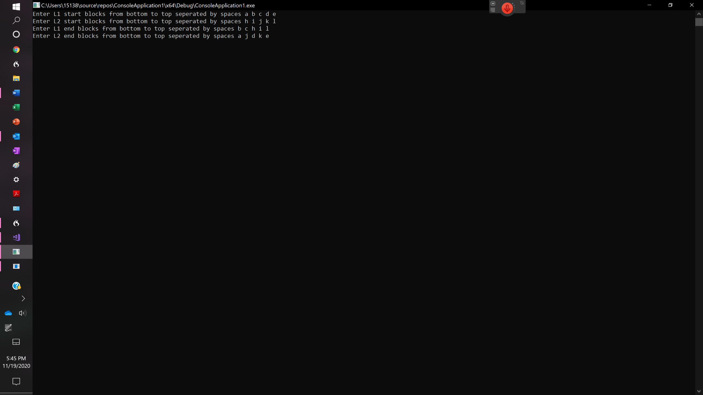

Figure 1 This figure shows this figure shows how to input the starting state and end state into the program once execution has started.

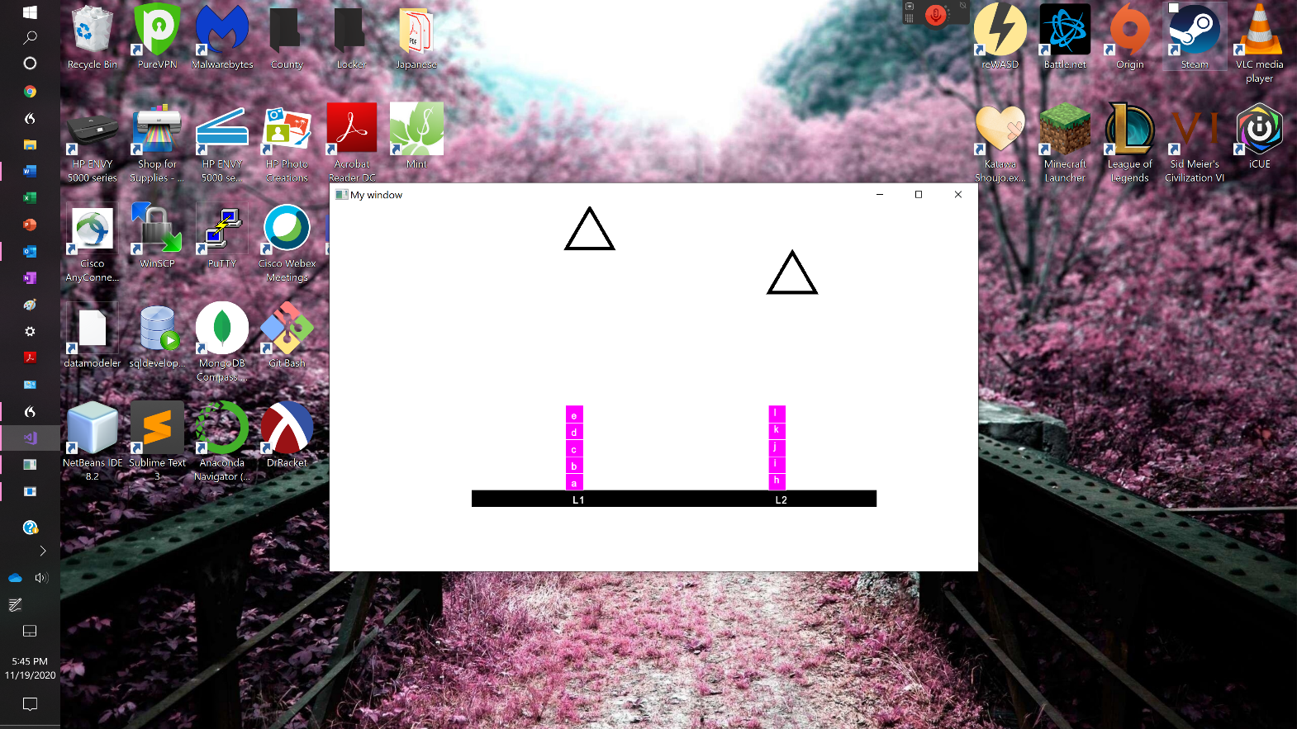

Figure 2 The starting state.

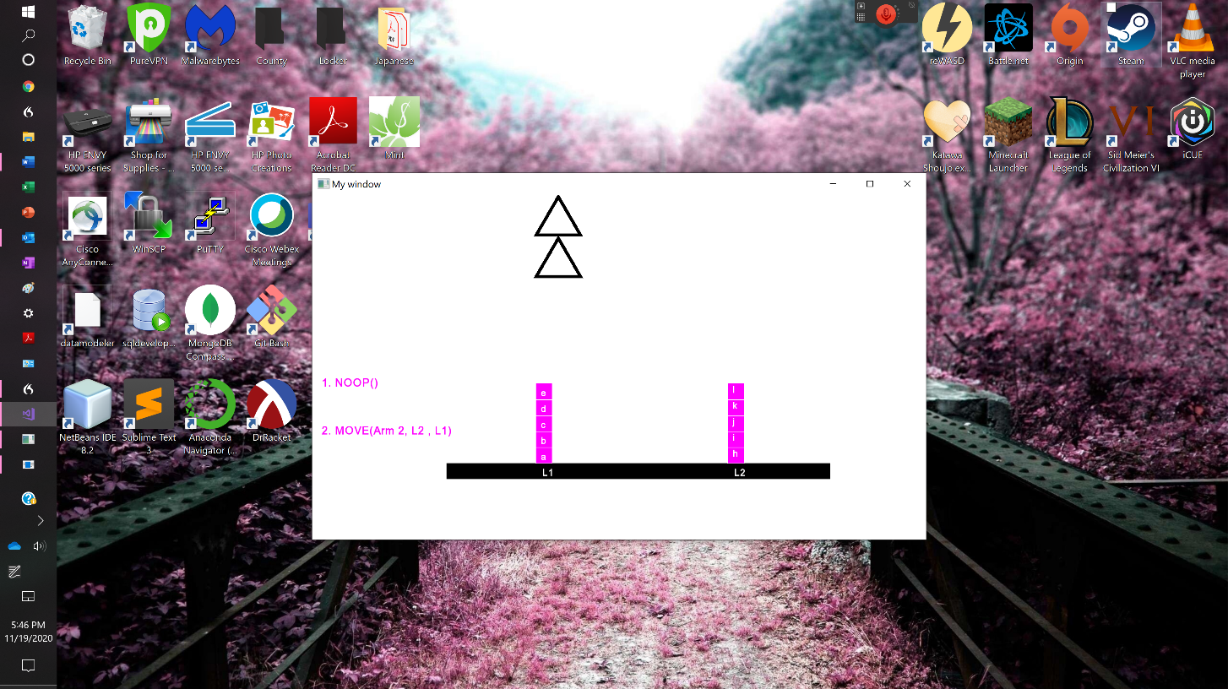

Figure 3 At this stage, the arms have determined that the first block that needs to be sorted in L1 is b, and they have determined that the b block is located at L1, so the second arm moves over. At this point, this state they got the highest rank was determined at step 5c.

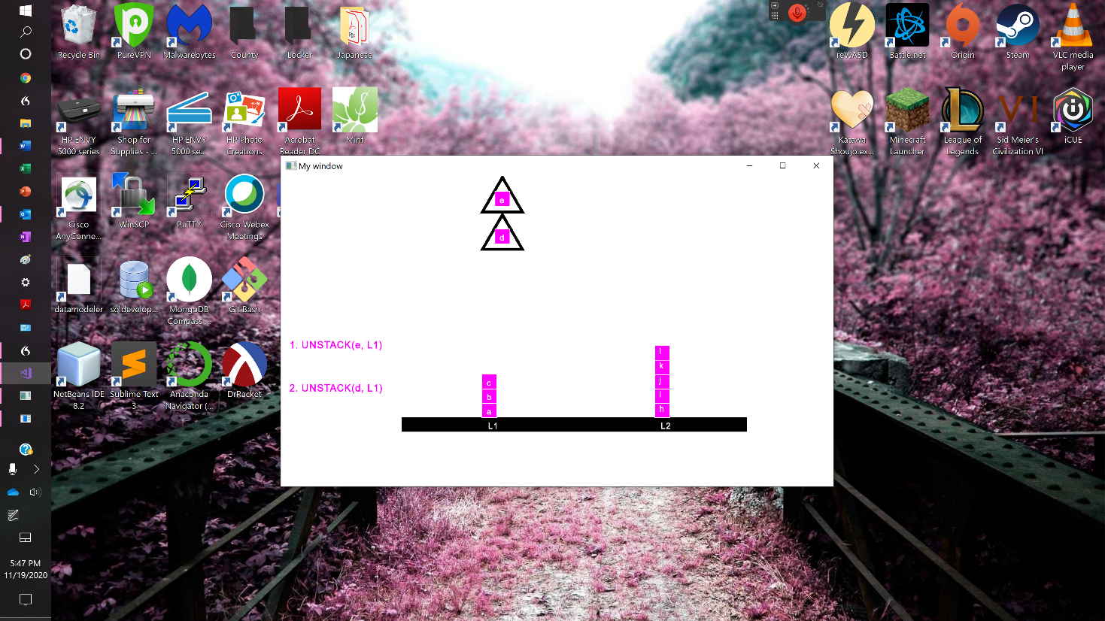

Figure 4 At this stage, the arms have started grabbing blocks from L1 to obtain block b. This state was ranked by step 5a.

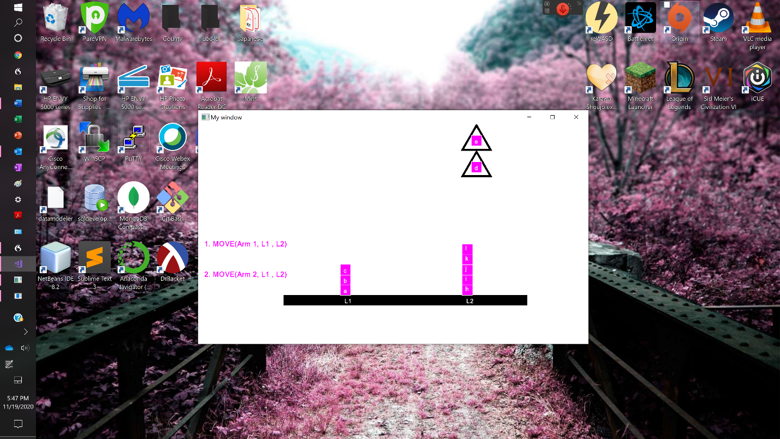

Figure 5 at this stage the arms are still searching for block b, so they have to prepare to place the extra blocks that they found on L2. Therefore, they can continue searching. The state was ranked by step 5b.

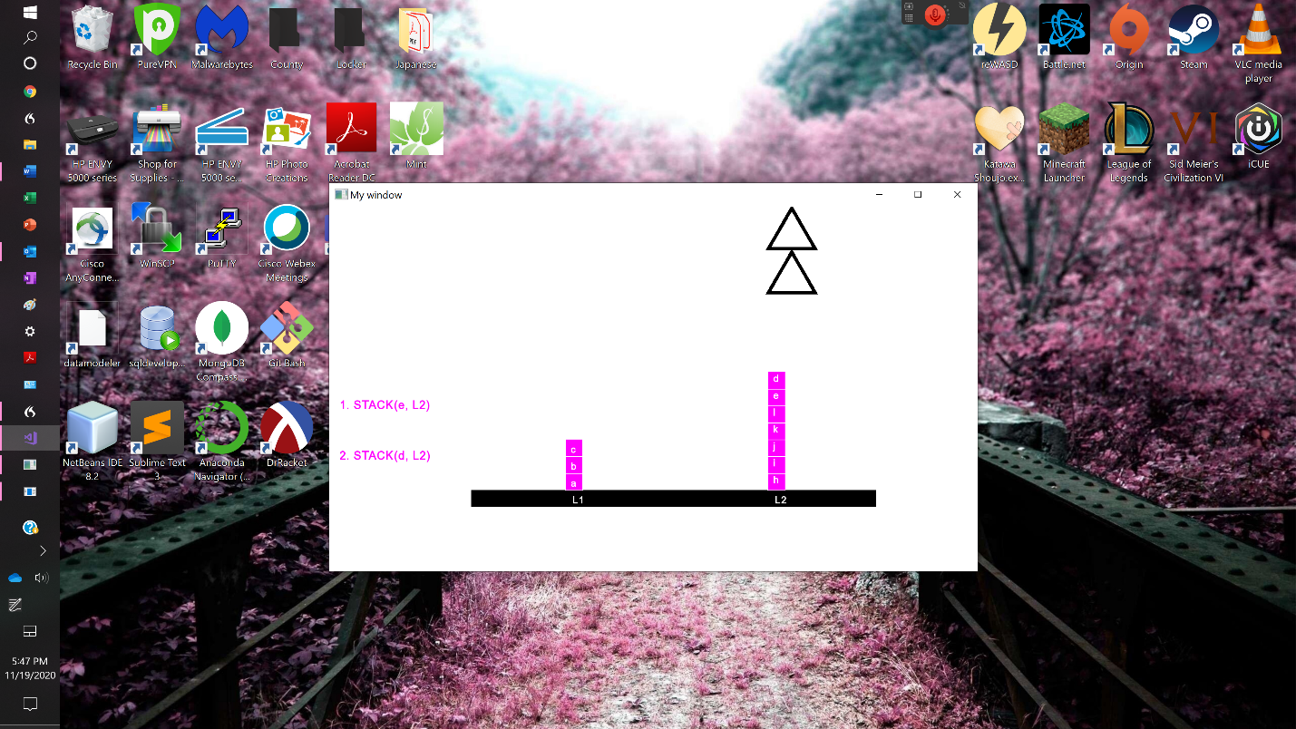

Figure 6 At this stage, the arms have placed the extra blocks, so he can now prepare to go back to L1 to continue searching for block b. This state was ranked by step 5d.

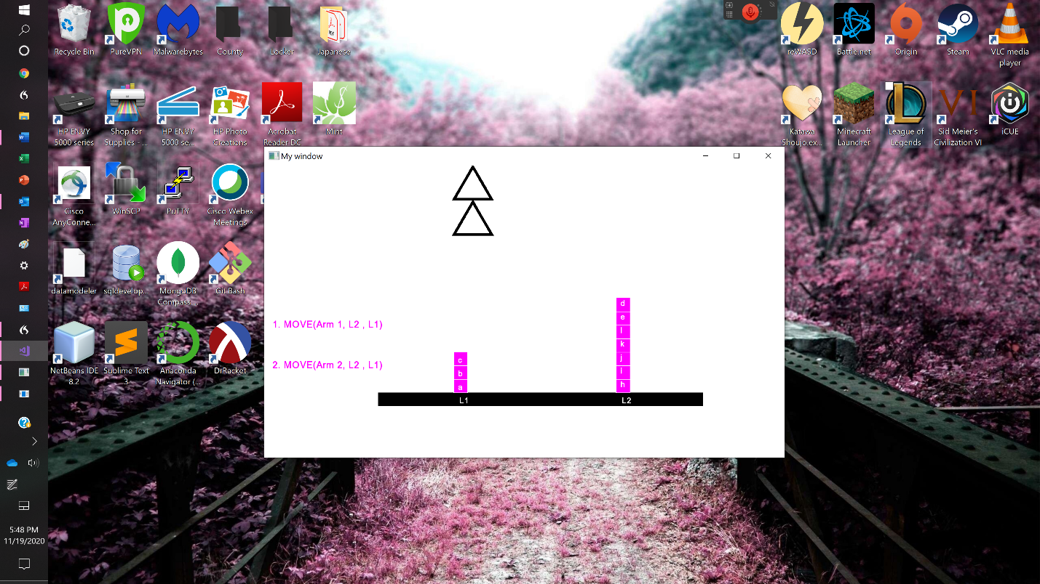

Figure 7 The arms are now ready to move back to L2 to grab more blocks. At this point, this state they got the highest rank was determined at step 5c.

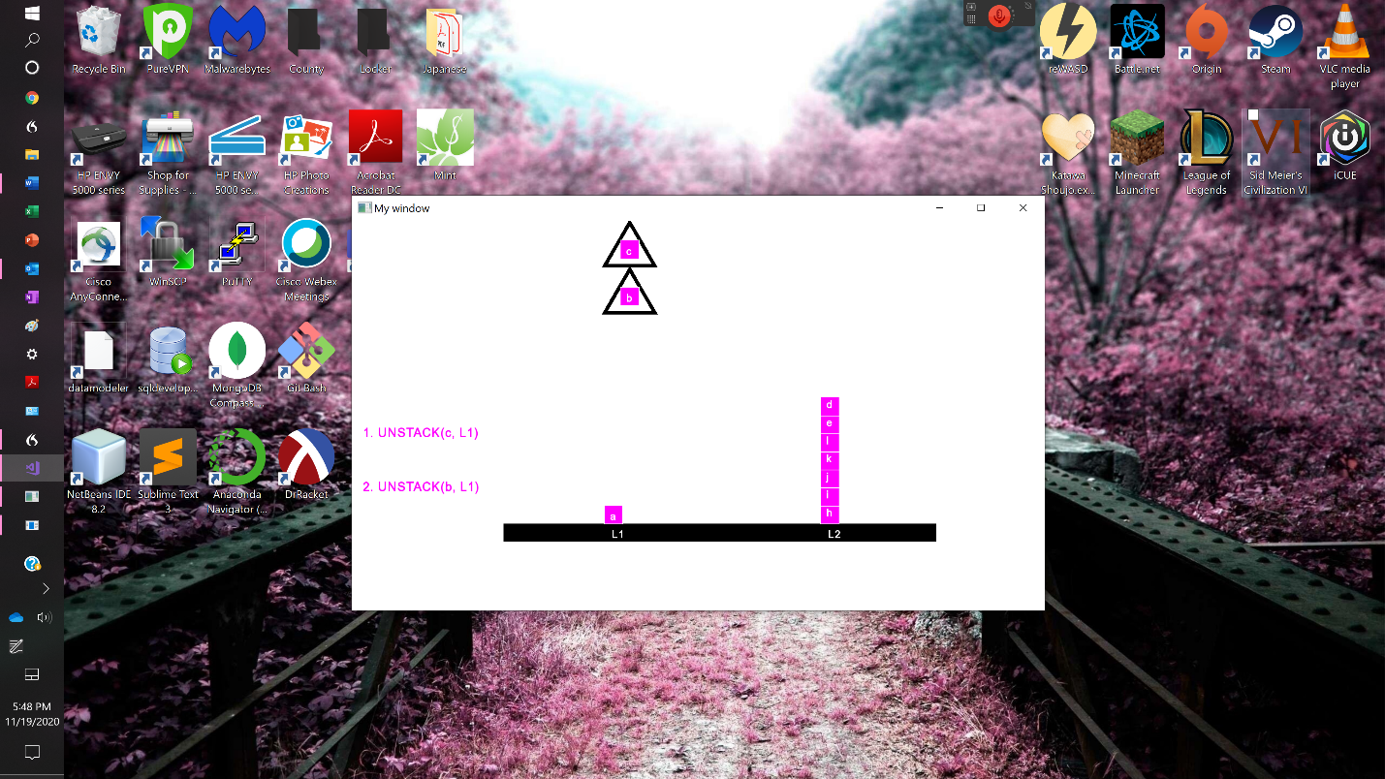

Figure 8 The arms now know that they picked up the block that they are looking for. The state was ranked by step 3a.

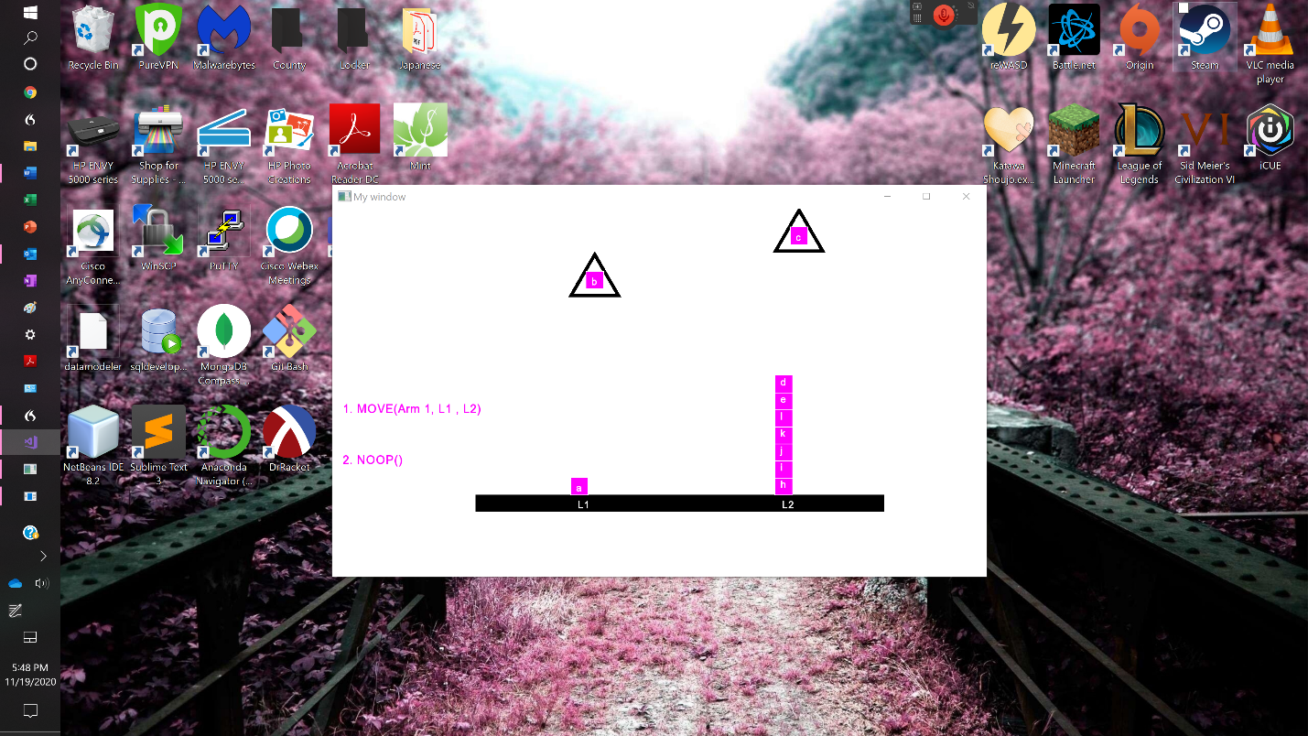

Figure 9 The arm that is holding the block to be sorted (b) stays over L1 because L1 is the list of currently being sorted. The other arm continues removing unsorted blocks from L1 until block b can be placed in the proper order. The state was ranked by step 3b.

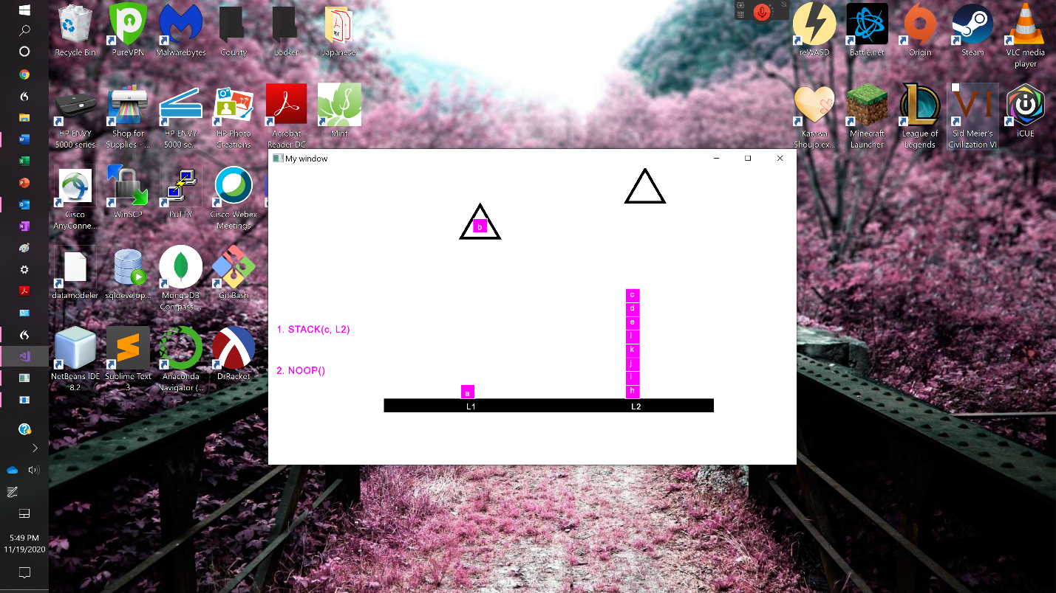

Figure 10 The arm holding the c block over L2 can now place it, so it can continue to move other blocks until block b can be placed. This state was ranked by step 3d.

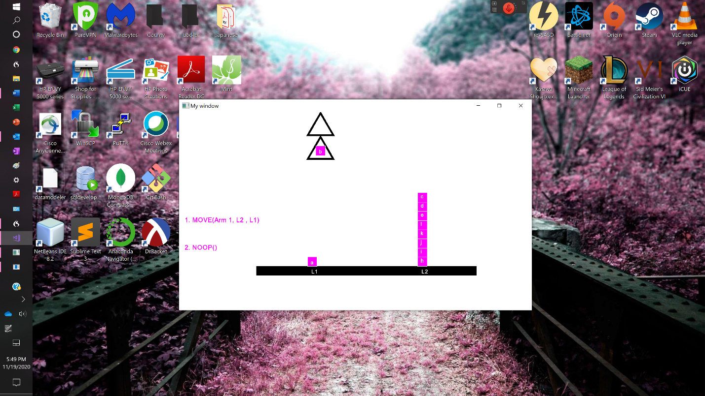

Figure 11 Now the arm that is not holding block b can move back to L1 to pick up another out place block. The state was ranked by step 3c.

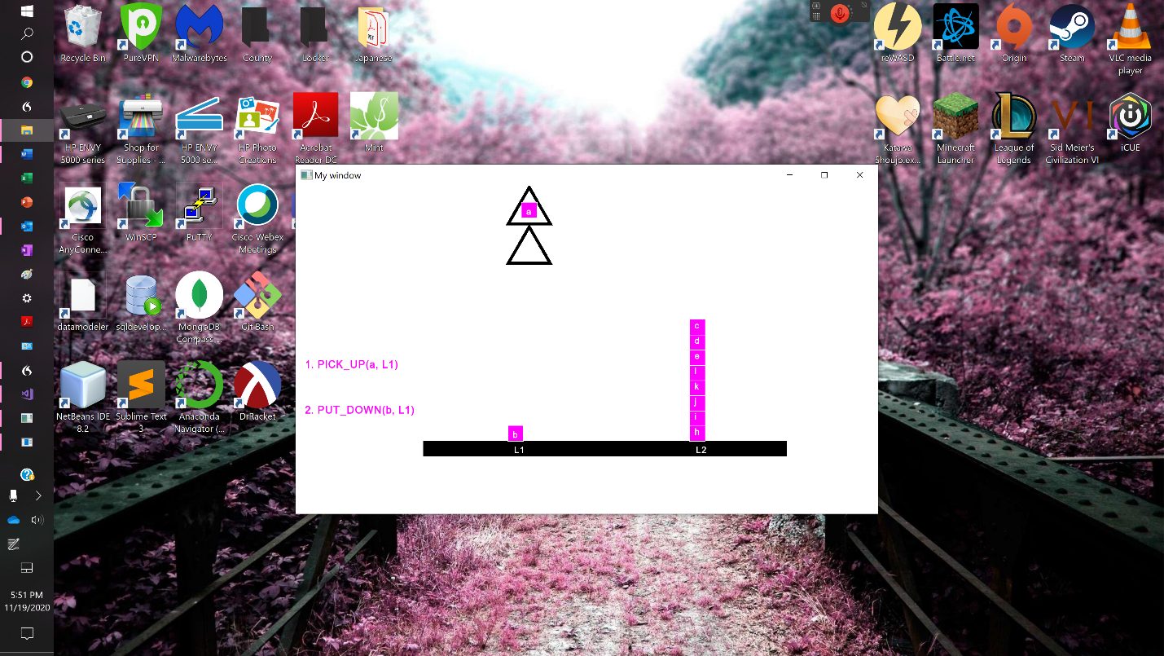

Figure 12 The arm that was not holding block b pick up block a, and then block b can be placed in its place. The state was ranked by step 1.

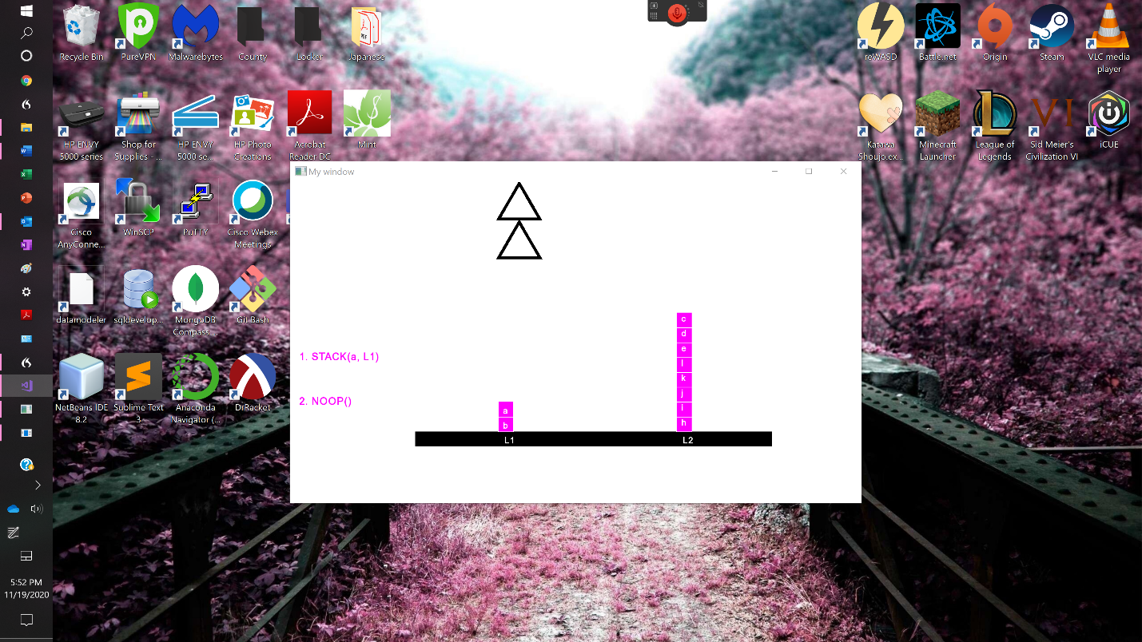

Figure 13 Block b is now placed and sorted so the arm can drop block a to prepare to look for the next block to be sorted. This state was ranked by step 5d.

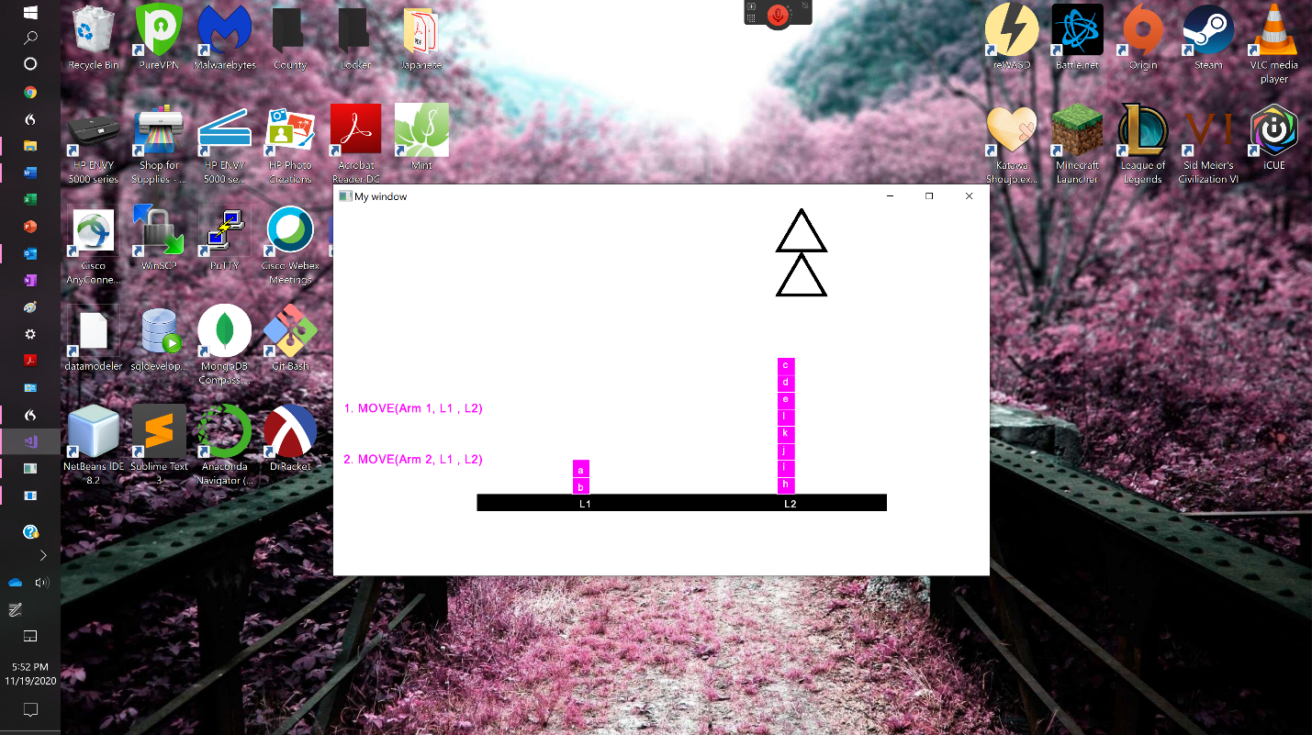

Figure 14 Both arms now move over to L2 and repeat the above process to look for and place the next block. This state was ranked by step 5c.

The above execution would continue by sorting all of L1 and then sorting all of L2. It should be noted that if the arm holding the b block was not initially over L1, the algorithm includes a step that would move the arm to L1 after it had the b Block.

Conclusions

Overall, this algorithm executes efficiently as far as timing goes. Before this algorithm was created, a previous version of the algorithm did basic depth first search, without ranking any of the child states. This algorithm would take at least eight hours to run on the above problem. This new and improved algorithm with the ranking system only takes roughly 45 seconds to run the above problem which is a monumental improvement.

In addition, the ranking system allowed for easier debugging of the program while it was still in development. The ranking system causes the robot arms to follow a cycle when sorting the blocks, so it was much easier to determine where the arms completed an incorrect action based on what their actions probably should have been. This made finding errors in the program much simpler.

There were many unintentional and implicit decisions that were used in creating the ranking system that made it more efficient that it possibly could have been. For example, when the arms are still searching for a block, both arms search simultaneously instead of only one arm. There is no ranking system that considers when the block that is being searched for is clear (on the top of the stack and can be grabbed) because the ranking system is automatically programmed to cause the arms to pick up blocks, until one of them finds the block that they are searching for. This means that the algorithm does not have to check to see if the next block is at the top of the stack because that means one of the arms will grab it by default. A final example of efficiency is when a block can be placed in the correct order with only one block out of place. In the above example this is referencing figures 11 and 12. As one can see, the empty arm picks up block a and then the arm holding block b places it down in the correct order. This is because the highest ranked child state is the state with the largest number of new blocks placed. An alternative option to this solution is if the arm that was empty picks up block a and the other arm does nothing and then the final step would be the arm holding block b places it in the arm holding block a does nothing. This is obviously more inefficient because it requires more actions by the arms, and more states.

Future Improvements

This program could be improved in the future by determining the method to be able to sort L1 and L2 simultaneously instead of concurrently. This could allow for the algorithm to be completed with fewer arm actions and states, but it would require major updates to the ranking algorithm to consider not only the next block to be sorted for L1 or L2 individually, but simultaneously. This would mean the ranking system would probably have to initially consider the world like it is just sorting L1, but it will also have to determine from those child states which state would allow for L2 to be sorted quicker. This improvement is not currently being investigated because of its magnitude and computational difficulty but would be an interesting problem to investigate in the future.

The state rankings could also be improved to allow arms to move independently when searching for the next block to be placed. This would allow for an empty arm to start searching for the next block to be placed instead of performing NOOP when the other arm is placing another block correctly. However, while this would reduce the move count slightly, the ranking system would have to search for more state conditions, meaning the algorithm to find the end state could be slower.

Another minor improvement could be easily done on the graphical user interface. For the time being, the program only displays the current state of execution for three seconds. However, the images for the graphical user interface were stored so that the states could be drawn simultaneously in the program window at increasing lower positions. Then the window view is updated and slid down so the most current state can be viewed. This means that a simple improvement would be to include a scrollbar. This will allow the user to look at the current and all of the past states after execution is completed.

References

Graphics

“Simple and Fast Multimedia Library.” SFML, www.sfml-dev.org/.

“Tutorials for SFML 2.5.” 2.5 Tutorials (SFML / Learn), www.sfml-dev.org/tutorials/2.5/.